**Name Lovepreet Singh**

**ID**

**Title: Hospital Manager**

# Section 1- Project planning and design

## Task 1 - Identify the problem

Main Problem: To discontinue the problem of people standing in line for long time for appointment and to ask doctor schedule and provide a facility to book a appointment online and see the Doctor schedule.

My client Manjinder told me about the daily situation at hospital and other various problems faced by people regarding this problem. He discussed with me about facilities that we will provide in our website now and later on if they love my work and then they will continue to other schedules with me.

I asked them regarding which kind of security feature they are looking for their website and what would be the client usage of the website and then I explained idea of roadmap of the website.

Afterward we discuss about meeting date and ended up the Conversation.

## Task 2 - Define and document requirements

## Scope :

The scope of website is that customer will enter details and book a seclude meeting.

## Features

|  |  |
| --- | --- |
| Users | Functional |
| Clerk | * Login/logout * Register new clerk as well as new doctor in system * Clerk has more authority like to maintain all details of Department, doctor, doctor schedules and capable to view all booking registered online. |
| Doctor | * Login/Logout * Doctor capable to view his/her patient appointment * Login using valid credentials |
| Patient | * Login/Logout * Registered Patient capable to book their appointment with available doctor * Registered Patient can view all his/her previous or future appointment done by himself/herself * Login using valid credentials |
|  | Non- Functional |
|  | * High speed * Fast Loading time * High performance and security * All browsers compatibility. |

## Time-

Total projected time to complete the project, including the schedule was 17 days that is explained below

|  |  |  |  |
| --- | --- | --- | --- |
| Task | Start date | End date | Days |
| Study about the project | 25 Oct | 28 Oct | 2 |
| Planning | 29 Oct | 1 Nov | 1 |
| Requirements | 2 Nov | 5 Nov | 2 |
| Design and Prototype | 6 Nov | 10 Nov | 4 |
| Development | 11 Nov | 15 Nov | 5 |
| Testing | 16 Nov | 16 Nov | 1 |
| Optimization | 17 Nov | 17 Nov | 1 |

## Cost –

### The total of reaches $ 2500

### Total Hours: 100

### Per hour: $ 25

### Total: $ 25 * 100 = $ 2500

## Project management

Phases of project management

Phase 1: Project Initiation

This is the start of the project, and the goal of this phase is to define the project at a broad level. This phase usually begins with a business case. This is when you will research whether the project is feasible and if it should be undertaken. If feasibility testing needs to be done, this is the stage of the project in which that will be completed.

Phase 2: Project Planning

This phase is key to successful project management and focuses on developing a roadmap that everyone will follow. This phase typically begins with setting goals and going to start and project of Hospital Manager

Phase 3: Project Execution

This is the phase where deliverables are developed and completed. This often feels like the meat of the project since a lot is happening during this time, like status reports and meetings, development updates, and performance reports and we showed our work once to the client

Phase 4: Project Performance/Monitoring

This is all about measuring project progression and performance and ensuring that everything happening aligns with the project management plan and i check my performance daily

Phase 5: Project Closure

After testing and implantation and optimization we send project to client

## Risk management-

Project risk management is the process of recognising, analysing, and responding to any risk that develops during the course of a project's life cycle in order to keep the project on track and accomplish its objectives.

Recognize the Threat

Find people with appropriate experience and set up interviews with them so you can acquire the data you'll need to both identify and mitigate the risks. Consider how many things could go wrong. Take note of them. Do the same thing with data from previous projects. Your list of potential dangers has now enlarged.

Examine the Threat

Risk analysis is difficult. There's never enough information to go around. Of course, much of that data is complicated, but most sectors have best practises that can aid your research. You might be shocked to learn that your organisation already has a method in place for this.

Risks should be prioritised.

## You can’t just set forces against a risk without tracking the progress of that initiative. That’s where the monitoring comes in. Whoever owns the risk will be responsible for tracking its progress towards resolution.

## Gantt chart

|  |  |  |  |  |
| --- | --- | --- | --- | --- |
| **Tasks** | **Week-1** | **Week-2** | **Week-3** | **Week-4** |
| Brainstorming and analysis |  |  |  |  |
| Planning and initial meeting Project Proposal document. |  |  |  |  |
| Database Design and UI Design |  |  |  |  |
| Identity framework implementation |  |  |  |  |
| Coding for admin and reporter |  |  |  |  |
| Testing |  |  |  |  |
| Final Documentation and closing |  |  |  |  |

## Task 3 - Design mockups

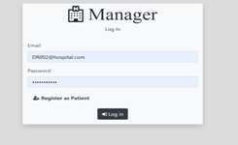

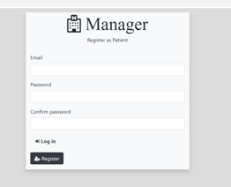

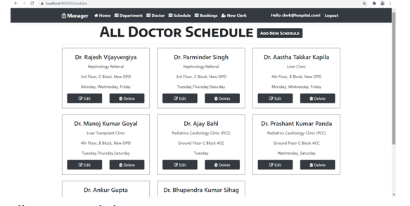

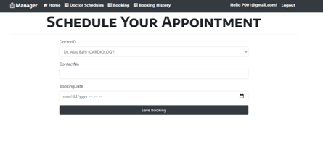

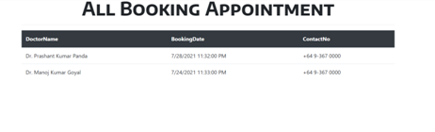

# Section 2 – Project development

## Task 4 – Coding

Application in Project name folder

## Task 5- usability testing

Task name:

Task 1- User Login

Task 2- Register New User

Task 3 – Book a Appointment

Task 4- Schedule Appointment

User Details –

User 1 : Gobind, male 24 student

User 2 – Priya, Female, Manger

User 3 – Love, 24 Male , student

Results

|  |  |  |  |  |
| --- | --- | --- | --- | --- |
| user | Task 1 | Task 2 | Task 3 | Task 4 |
| User 1 | **Completed** | **Not completed** | **Completed** | **Completed** |
| User 2 | **Able to login** | **Registered new user** | **Booked a Appointment** | **Working** |
| User 3 | **Login Success in less time** | **Registration done** | **Worked fine** | **Not working** |

## Task 6 - Meet with your client

Submit meeting form

Client Meeting:

|  |
| --- |
| Meeting Details |
| * Date and time: 1-Nov-2021 * Location: New Zealand |
| Attendees: Developer Lovepreet Singh and Client Manjinder Singh |
| Agenda: Points to be covered in Hospital Manager |
| Discussion (Important Points): Login, Register , Doctor Schedule |
| My To Dos (Actions): Notes written of TO DO |
| Questions requiring Follow- Up: About adding Contact us something like as |
| Comments: Take care of managing data |
| Next meeting  Date and Time: 9- Nov-2021 10:00 am  Location: New Zealand  Agenda: Show Work Done |

**Appendix 3**

**Client Review Form**

My developer’sname: Lovepreet Singh

This form is intended to let you review the communication skills of your developer for this assignment. Your review will partly count towards their final mark. Do not take into account technical skills.

# Grading scale

You must grade your developer for each item listed in the tables below. 1 being the lowest, 5 the highest.

|  |  |  |  |  |
| --- | --- | --- | --- | --- |
| **1** | **2** | **3** | **4** | **5** |
| Strongly disagree | Disagree | Ok | Agree | Strongly agree |

# Review your developer

|  |  |  |
| --- | --- | --- |
| **Item** | **Grade** | **Comment** |
| Communicated clearly and effectively | 5 |  |
| Kept you informed of the progress | 4.5 |  |
| Met timelines | 3 |  |
| Responded promptly to problems | 5 |  |
| Met overall project objectives | 4.5 |  |
| Was open to new ideas and suggestions | 5 |  |
| Was easy to work with | 4 |  |

Comments

Provide any extra comments on your developer’s communication skills and professionalism.

It was Difficult work but he did it very well

## Signed by Client

|  |  |
| --- | --- |
| **Signature: Manjinder Singh** | **Date: 18-nov-2021** |
| **Name: Manjinder Singh** | **Title: Hospital Manager** |
| **Contact details (email/Tel):** | |

# Section 3– Presentation and reflection

## Task 7- Presentation

In the project folder

## Task 8 - Software development life cycle stages

Review your Software development life cycle stages

### Planning

The first step of software development is planning about things to add in the project and discussing about the business the client deals with and kind of software they want to build.

### Requirement

And other most important task before coding the actual software is taking down all the requirements of the client and deeply discuss the pros and cons of the things he is saying to enter and also think from coding prospective to weather this requirement client is offering can be fulfilled or not .

### Software Design and prototyping

After noting down the requirement we will start designing the software and making the prototype of the forms and all other things that are required according to the need.

### Software Development

After the prototypes of the software are done then we apply functionality to the website and attach the code to the with database

### Testing

After completing all the above tasks we will now test the application find of all the errors and of designing and functionalities from the website after solving errors and we need to retest the application and should repeat this process until application turn to the perfection.

## Task 9- Project management

## Sharing my experience about the Real time project Development

# What I learned

It was the wonderful experience working on live project and now I am happy that I completed the project on time and learned many useful things like managing the project and database

# Limitations

Client was very specific about the things he was having in mind and I worked totally like that he told me his requirement I made the basic mockups and showed him in a meeting then we discussed about the table structure that we can use the website

# Difficulties

As full project was based on record keeping so I need to maintain the database more properly and use the quires of CRUD operation wisely. I managed to do with help of my teacher and then I completed that structure and really it was difficult part for me.

# Time

I took more than 30 days to complete my full project with testing and other things more time was consumed in development part as I completed designing in 10 days but development took long to complete.